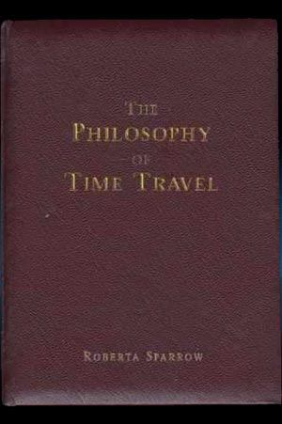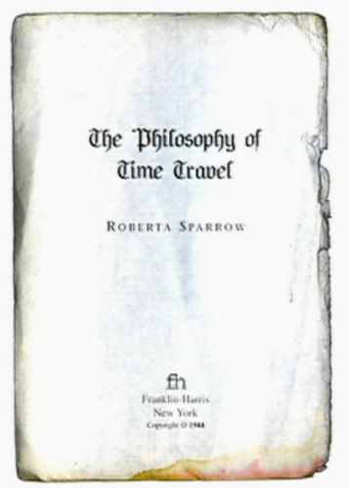

|  |  |  |  |  |  |  |  |  |  |  |  |  |  |  |  |  |  |  |  |  |  |  |  |  |  |  |  |  |  |  |  |  |  |  |  |  |  |  |  |  |  |  |  |  |  |  |  |  |  |  |  |  |  |  |  |  |  |  |  |
| --- | --- | --- | --- | --- | --- | --- | --- | --- | --- | --- | --- | --- | --- | --- | --- | --- | --- | --- | --- | --- | --- | --- | --- | --- | --- | --- | --- | --- | --- | --- | --- | --- | --- | --- | --- | --- | --- | --- | --- | --- | --- | --- | --- | --- | --- | --- | --- | --- | --- | --- | --- | --- | --- | --- | --- | --- | --- | --- | --- |
| http://www.ruinedeye.com/cd/bfore.jpg | |  |  | | --- | --- | |  | | | **foreword** | | |  | | | I would like to thank the sisters of the Saint John | | | Chapter in Alexandria, Virginia for their support | | | (in my decision). | | |  | | |  | By the grace of God, they are: | |  |  | |  | Sister Eleance Lewis | |  | Sister Francesca Godard | |  | Sister Helen Davis | |  | Sister Catherine (Arnold) | |  | Sister Mary Lee Pond | |  | Sister Virginia (Weaver) | |  | | | ....This intent(?) of this short book is for it to be used as a | | | simple and direct guide in a time of great danger. | | |  | | | I pray that this is merely a work of fiction. | | |  | | | If it is not, then I pray for you, the reader of this book. | | |  | | | ....If I am still alive when the events | | | foretold in these pages occur, then I hope that you | | | will find me before it is too late. | | |  | | | Roberta Ann Sparrow | | | October, 1944 | | |

|  |  |  |  |  |  |  |  |  |  |  |  |  |  |  |  |  |  |  |  |  |  |  |
| --- | --- | --- | --- | --- | --- | --- | --- | --- | --- | --- | --- | --- | --- | --- | --- | --- | --- | --- | --- | --- | --- | --- |
| http://www.ruinedeye.com/cd/book2.jpg | |  | | --- | |  | | Chapter One | | **The Tangent Universe** | |  | | ....The Primary Universe is fraught with great peril. | | War, plague, famine and natural disaster are common. | | Death comes to us all. | |  | | ....The Fourth Dimension of Time is a stable construct, | | though it is not impenetrable. | |  | | ....Incidents when the fabric of the fourth dimension | | becomes corrupted are incredibly rare. | |  | | ....If a Tangent Universe occurs, it will be highly | | unstable, sustaining itself for no longer than several | | weeks. | |  | | ....Eventually it will collapse upon itself, forming a | | black hole within the Primary Universe capable of | | destroying all existence. | |

|  |  |  |  |  |  |  |  |  |  |  |  |  |  |
| --- | --- | --- | --- | --- | --- | --- | --- | --- | --- | --- | --- | --- | --- |
| http://www.ruinedeye.com/cd/book3.jpg | |  | | --- | |  | | Chapter Two | | **Water And Metal** | |  | | Water and Metal are the key elements of Time Travel. | | k | | ....Water is the barrier element for the construction of | | Time Portals used as gateways between Universes at the | | Tangent Vortex. | | k | | ....Metal is the (transitional) element for the construction | | of Artifact Vessels. | |

|  |  |  |  |  |  |  |  |  |  |  |  |  |  |  |  |  |  |  |  |  |  |  |  |  |
| --- | --- | --- | --- | --- | --- | --- | --- | --- | --- | --- | --- | --- | --- | --- | --- | --- | --- | --- | --- | --- | --- | --- | --- | --- |
| http://www.ruinedeye.com/cd/book4.jpg | |  | | --- | |  | | Chapter Four | | **The Artifact And** | | **The Living** | |  | | ....When a Tangent Universe occurs, those living | | nearest to the Vortex will find themselves at the epi- | | center of a dangerous new world. | |  | | ....Artifacts provide the first sign that a Tangent | | Universe has occurred. | |  | | ....If an Artifact occurs, the Living will retrieve it with | | great interest and curiosity. Artifacts are formed from | | metal, such as an Arrowhead from an ancient Mayan | | civilization, or a Metal Sword from Medieval Europe. | |  | | ....Artifacts returned to the Primary Universe are often | | linked to religious iconography; as their appearance on | | Earth seems to defy logical explanation. | |  | | ....Divine Intervention is deemed the only logical con-. | | clusion for the appearance of the Artifact. | |

|  |  |  |  |  |  |  |  |  |  |  |  |  |  |  |  |  |  |  |  |  |  |
| --- | --- | --- | --- | --- | --- | --- | --- | --- | --- | --- | --- | --- | --- | --- | --- | --- | --- | --- | --- | --- | --- |
| http://www.ruinedeye.com/cd/book5.jpg | |  | | --- | |  | | Chapter Six | | **The Living Receiver** | |  | | ....The Living Receiver is chosen to guide the Artifact | | into position for it's journey back to the Primary Universe. | |  | | No one knows how or why a Receiver will be chosen. | |  | | ....The Living Receiver is often (blessed) with a Fourth | | Dimensional Power(s). These include increased strength, | | telekinesis, mind control, and the ability to conjure | | fire and water. | |  | | ....The Living Receiver is often tormented by terrifying | | dreams, visions and auditory hallucinations during his | | time within the Tangent Universe. | |  | | ....Those surrounding the Living Receiver, known as the | | Manipulated, will fear him and try to destroy him. | |

|  |  |  |  |  |  |  |  |  |  |  |  |  |  |  |  |  |
| --- | --- | --- | --- | --- | --- | --- | --- | --- | --- | --- | --- | --- | --- | --- | --- | --- |
| http://www.ruinedeye.com/cd/book6.jpg | |  | | --- | |  | | Chapter Seven | | **The Manipulated** | | **Living** | |  | | ....The Manipulated Living are often the close friends | | and neighbors of the Living Receiver. | |  | | ....They are prone to irrational, bizarre, and often | | violent behavior. This is the unfortunate result of their | | task, which is to assist the Living Receiver in returning | | the Artifact to the Primary Universe. | |  | | ....The Manipulated Living will do anything to save | | themselves from Oblivion. | |

|  |
| --- |
|  |
| http://www.ruinedeye.com/cd/book7.jpg | |  | | --- | |  | | Chapter Ten | | **The Manipulated** | | **Dead** | |  | | ....The Manipulated Dead are more powerful than the | | Living Receiver. If a person dies within the Tangent | | Dimension, they are able to contact the Living | | Receiver through the Fourth Dimensional Construct. | |  | | The Fourth Dimensional Construct is made of Water. | |  | | ....The Manipulated Dead will manipulate the Living | | Receiver using the Fourth Dimensional Construct (see | | Appendix A and B). | |  | | ....The Manipulated Dead will often set an Ensurance | | Trap for the Living Receiver to ensure that the Artifact | | is returned safely to the Primary Universe. | |  | | ....If the Ensurance Trap is successful, the Living | | Receiver is left with no choice but to use his Fourth | | Dimensional Power to send the Artifact back in time | | into the Primary Universe before the Black Hole | | collapses upon itself. | |
|  |  |

|  |  |  |  |  |  |  |  |  |  |  |  |  |  |  |  |  |  |  |  |  |  |  |  |  |  |
| --- | --- | --- | --- | --- | --- | --- | --- | --- | --- | --- | --- | --- | --- | --- | --- | --- | --- | --- | --- | --- | --- | --- | --- | --- | --- |
| http://www.ruinedeye.com/cd/book10.jpg | |  | | --- | |  | | Chapter Twelve | | **Dreams** | |  | | ....When the Manipulated awakens from their Journey | | into the Tangent Universe, they are often haunted by | | the experience in their dreams. | |  | | Many of them will not remember. | |  | | ....Those who do remember the Journey are often over- | | come with profound remorse for the regretful actions | | buried within their Dreams, the only physical evidence | | buried within the Artifact itself, all that remains from | | the lost world. | |  | | ....Ancient myth tells us of the Mayan Warrior killed | | by an Arrowhead that had fallen from a cliff, where | | there was no Army, no enemy to be found. | |  | | ....We are told of the Medieval Knight mysteriously | | impaled by the sword he had not yet built. | |  | | We are told that these things occur for a reason. | |

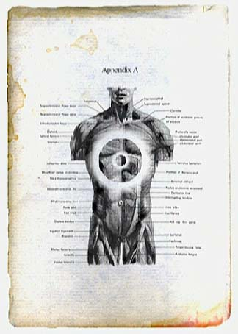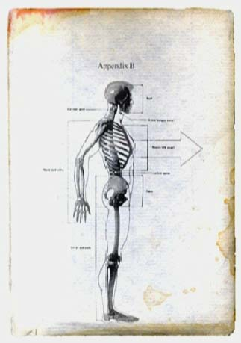

|  |  |  |  |  |  |  |  |  |  |  |  |  |  |  |
| --- | --- | --- | --- | --- | --- | --- | --- | --- | --- | --- | --- | --- | --- | --- |
| http://www.ruinedeye.com/cd/book11.jpg | |  | | --- | |  | | **Notes** | |  | | Living Receiver | | Donald [or maybe Donnie] Darko (died October 2, 1988) | |  | | Manipulated Dead | | Frank (Anderson) | | Gretchen Ross (not her real name) | |  | | Manipulated Living | | (everyone else in the film - list includes Donnie's family, friends, enemies, Roberta Sparrow, etc. // note after Jim Cunningham's name reads, I think, "died October 1988") | |  | |

Lost Chapters: number three, number five, number eight, number nine and number eleven.